Unit 10: Sequences

Lesson 1: Arithmetic Sequence

Objectives:

* I can identify an arithmetic sequence
* I list terms in an arithmetic sequence
* I can identify the common difference in an arithmetic sequence
* I can calculate the nth term of a sequence

Agenda:

* Video
* Practice
* Application

Vocabulary:

Sequence, Arithmetic sequence, difference, initial term, nth term, Explicit rule.

Focus Questions:

1. What is an arithmetic sequence?
2. How do we write an explicit rule and a recursive rule for an arithmetic sequence?
3. What is the connection between arithmetic sequences and linear functions?

Homework: Worksheet 10-1.

Online support:

<https://www.khanacademy.org/math/algebra/sequences/introduction-to-arithmetic-squences/v/explicit-and-recursive-definitions-of-sequences>

<https://www.khanacademy.org/math/algebra/sequences/introduction-to-arithmetic-squences/v/arithmetic-sequences>

1) My plumber charges a $40 initial fee plus $50 per hour work on a job.

1. Write an equation that would determine the amount of money, M , the plumber would charge for a job lasting n hours.

b) What type of function is this? (linear, exponential, quadratic, etc?)

c) Use your equation to fill in the table of values below.

|  |  |  |  |  |  |
| --- | --- | --- | --- | --- | --- |
| # hours (n) | 1 | 2 | 3 | 4 | 5 |
| Money charged (M) |  |  |  |  |  |

**A sequence is a list of numbers in a particular order.**

Sequence of money charged: _____________________________

**This is an example of an arithmetic sequence.**

Some famous, and not so famous, examples of sequences.

Positive Odd Integers: 1, 3, 5, 7, 9, . . . Areas of squares: 1, 4, 9, 16, 25, . . .

Koch Snowflake growth: 1, 4, 16, 64, . . . Folds when folding paper in half: 1, 2, 4, 8, 16, . . .

Two important types of sequences are **arithmetic** sequences and **geometric** sequences (Lesson 2). Check whether the sequence is arithmetic or geometric, and fill in the missing number in each sequence.

|  |  |  |
| --- | --- | --- |
| **sequence** | **arithmetic** | **Geometric** |
| 1. 4, 7, 10, ________, 16, . . . |  |  |
| 1. 2, 4, 8, 16, ________, . . . |  |  |
| 1. 1, ________, 9, 27, 81, . . . |  |  |
| 1. 3.5, 6, 8.5, 11, _________, . . . |  |  |
| 1. 8, 12, 18, _________, 40.5, . . . |  |  |
| 1. ________, -5.5, -9.5, -13.5, . . . |  |  |
| 1. 256, 64, 16, 4, _________, . . . |  |  |
| 1. -4, 8, -16, 32, -64, _________, |  |  |

[](http://www.google.com/url?sa=i&rct=j&q=&esrc=s&source=images&cd=&cad=rja&uact=8&ved=0CAcQjRxqFQoTCNS-kpHRtscCFUYVPgodIZcGJg&url=http://www.iconarchive.com/tag/note&ei=Dj7VVdT_Dcaq-AGhrpqwAg&bvm=bv.99804247,d.cWw&psig=AFQjCNEaJ7JrrLdAnMMpC9qQ_QIbVkniSA&ust=1440124504468152)A **sequence** is a list of numbers in a particular order. Each number in a sequence is called a **term**. The first term is symbolized by , the second term is symbolized by , and so on. There are two major types of explicit sequences, arithmetic and geometric.

**1. Arithmetic Sequences**

An **arithmetic sequence** is a sequence in which each term after the first is found by adding a constant, called the **common difference**, *d*, to the previous term. The terms between any two non-consecutive numbers of an arithmetic sequence are called **arithmetic means**.

|  |  |  |
| --- | --- | --- |
| **Arithmetic** | **Equation Type**  Linear | **Formula** for the nth term:  where  is the initial term and  *d* is the common difference |

Let’s look at the arithmetic sequences from the “Do Now”. Identify the first term and the common difference, then use them to write an explicit equation.

first term () common explicit equation

difference (*d*)

a) **4, 7, 10, _____, 16, . . .** ________ _______ ___________________

b) **3.5, 6, 8.5, 11, _____, . . .** ________ _______ ___________________

c) **_____, -5.5, -9.5, -13.5, . . .** ________ _______ ___________________

d) Given an equation, you can find the sequence: 

Write the first 7 terms of the sequence: ___________________________________________________

e) Given  and the common difference of the arithmetic sequence is 6.

Write the first 4 terms of the sequence: __________________________________________

Write the explicit equation of this sequence: ______________________________________

**Find the 155th term of this sequence:**

**Practice**

**Example #1**: **Find the next term**

Find the next 4 terms of the arithmetic sequence 55, 49, 43, …

Find the common difference *d* by subtracting two consecutive terms. *d* = _______

Now add that to the third term of the sequence and continue adding.

The next 4 terms are: _______, _______, _______, _______

**Write a general rule for the sequence and simplify:**

**Example #2: Find a particular term**

Find the 250th term in the following sequence: **{** 2, 6, 10, 14, 18, …}

Find the common difference: *d* = _______

= _______ (first in sequence)

Substitute known values in the equation and solve:



**Example #3: Write an equation for the *nth* term (means the explicit rule, general rule)**

Write an equation for the nth term of the arithmetic sequence 8, 17, 26, 35, …

In this sequence, = _______ and *d* = _______.

[](http://www.google.com/url?sa=i&rct=j&q=&esrc=s&source=images&cd=&cad=rja&uact=8&ved=2ahUKEwjgmaTsweTaAhWunOAKHQyvAH4QjRx6BAgBEAU&url=http://www.yourturnnl.com/&psig=AOvVaw2U-b5q88KMIMSiGfqYcXgv&ust=1525264141210876)Use the nth term formula to write an equation. Then simplify.



****Name: Date:

Example 1: Identify ${ a}_{1} \left(first term \right), and common difference \left(d\right)for each$ sequences then decide if the sequences is an arithmetic sequence or not.

$$\left(1\right) A=\left\{3, 5, 7, 11, 24\right\} \left(2\right) B=\{-5,-2, 1, 4 ,7\}$$

Example 2: Find the next 4 terms of the arithmetic sequence 55, 49, 43, …

The next 4 terms are: _______, _______, _______, _______

Example 3: Find the 7th term in the following sequence: { 2, 6, 10, …..}

$a_{1}= d=$

Use the nth term formula to write an equation. Then simplify.



$$a_{7=}$$

Example 4: Write an equation for the nth term of the arithmetic sequence $1, 7, 13, 19, 25, 31, 37, 43,…….$

In this sequence, = _______ and *d* = _______.

Use the nth term formula to write an equation. Then simplify.



Example 5: Write an equation for the nth term of the arithmetic sequence $-9,-8,-7,-6 ,-5,…….$

In this sequence, = _______ and *d* = _______.

Use the nth term formula to write an equation. Then simplify.



Example 6: Growing Dot Problem: let’s look at the following example and discuss with your partner:

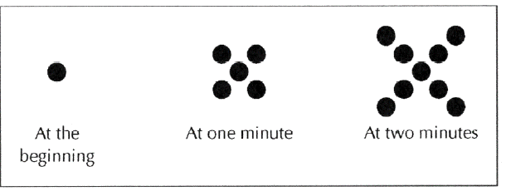

|  |  |  |  |  |  |
| --- | --- | --- | --- | --- | --- |
| M (minute) | 0 | 1 | 2 | 3 | 4 |
| D (dots) |  |  |  |  |  |

1. Assuming the sequence continues in the same way, how many dots are there at 3 minutes? 4 min?
2. List the number of the dots after each minute as a sequence from the beginning to min 4.
3. Identify $a_{1} and d$ for the sequence and write the ${n }^{th}$ term rule for the sequence.

Example 7:

A. If the pattern continues, list the first 6 terms of the following sequence.

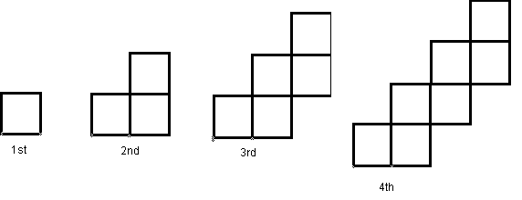

B. Identify $a_{1} and d$ for the sequence and write the ${n }^{th}$ term rule for the sequence.

c. Use the general rule to find $a_{25}$

Have you done few questions on the Regents review???